Springboot kafka with Topic Creation

Create Springboot app with web, devtool. Spring kafka dependencies.

Project Structure Looks as mentioned below.

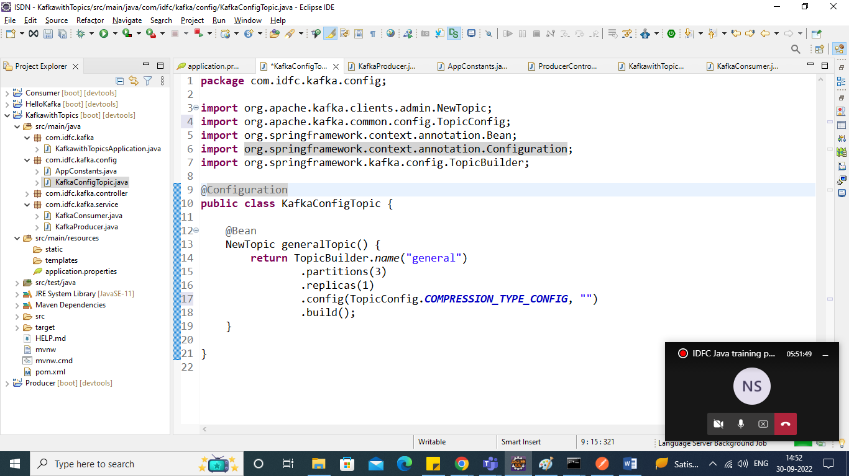

Let’s create A Topic Configuration

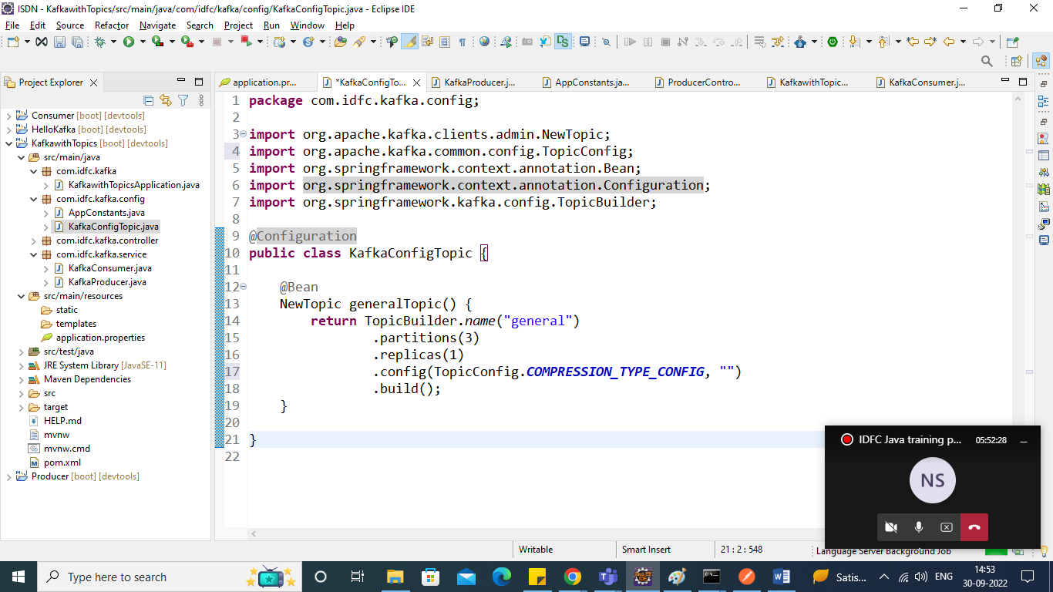

Create Constants class

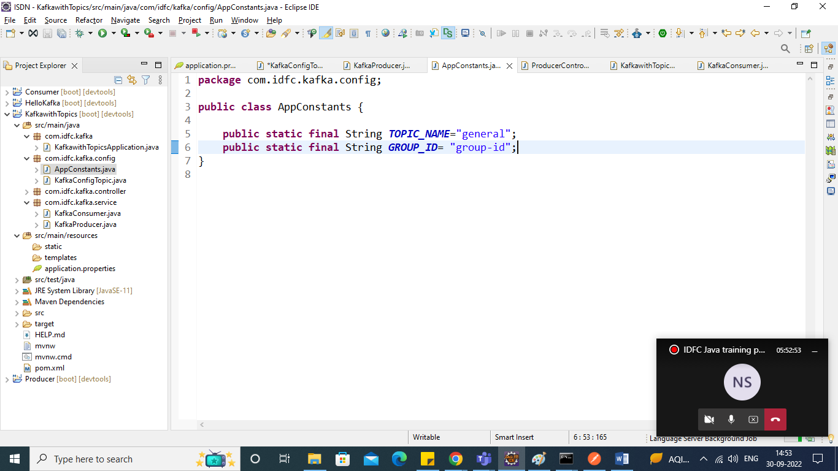

Edit application.properties file for producer and consumer Config

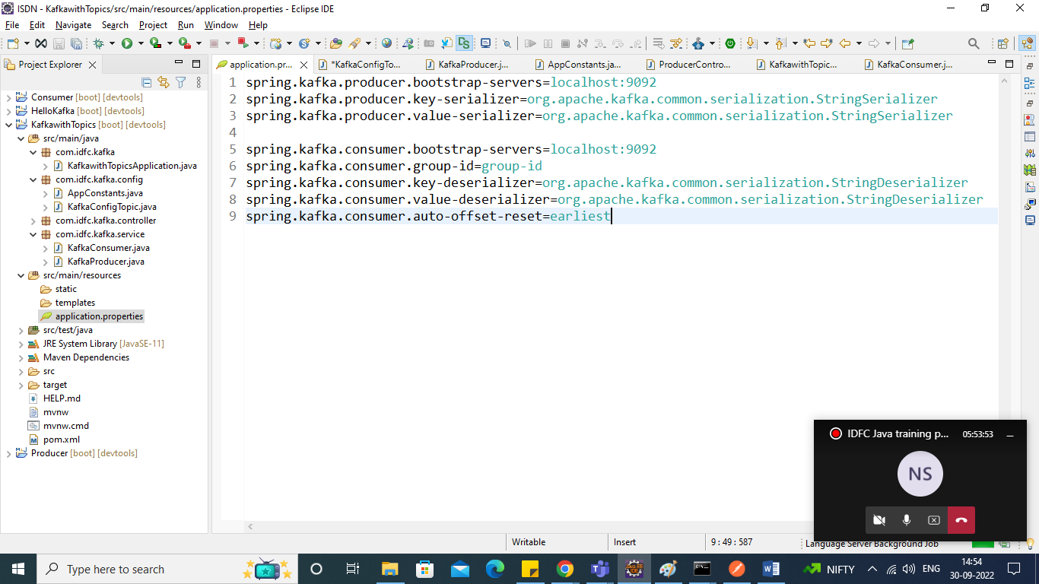

Create Class for KafkaProducer

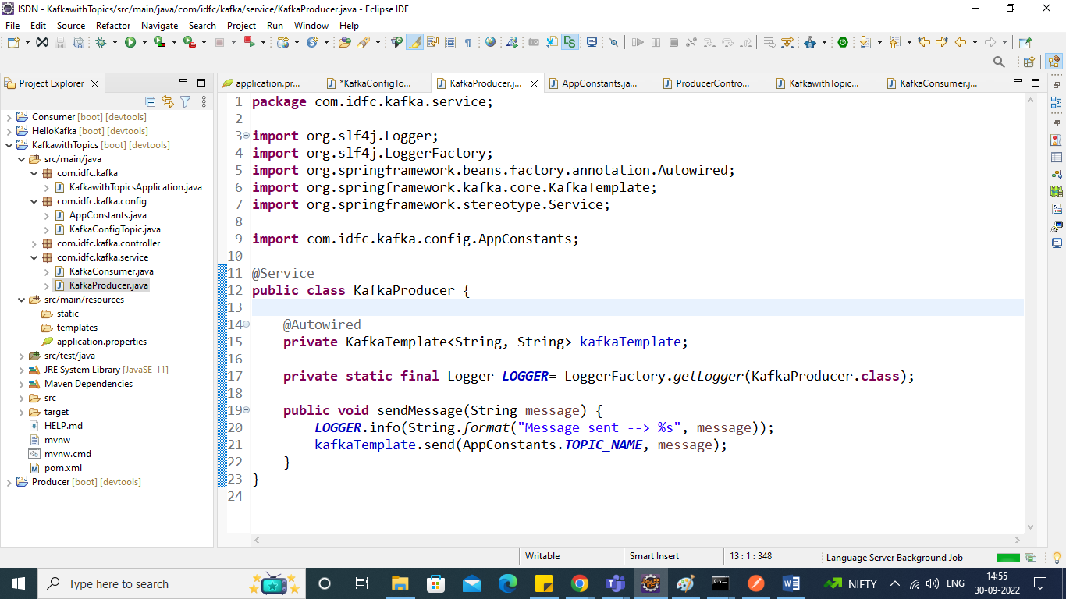

Create Controller

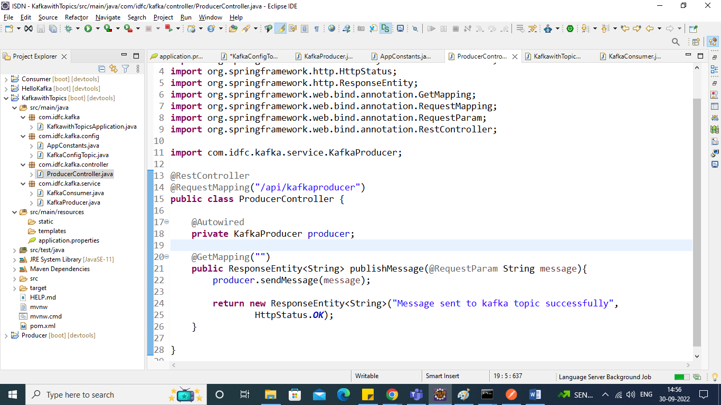

Run the Application Send the Request through POSTMAN and check in consumer console.

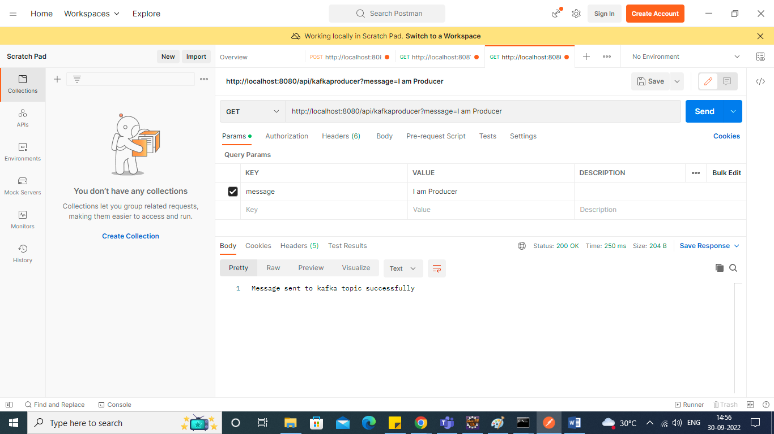

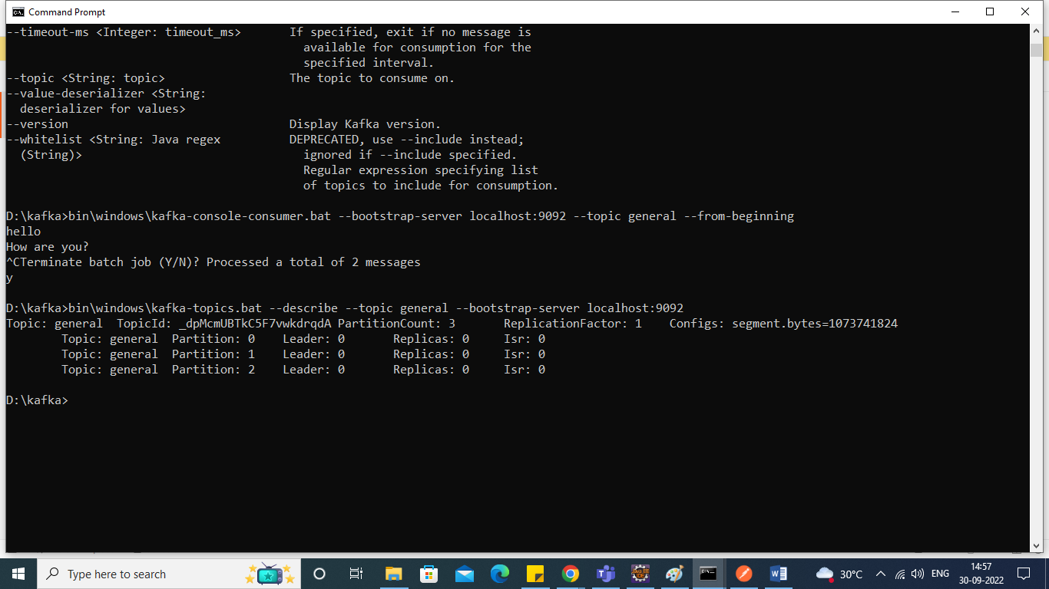

Check topic description as well.

Create KafkaConsumer Service.

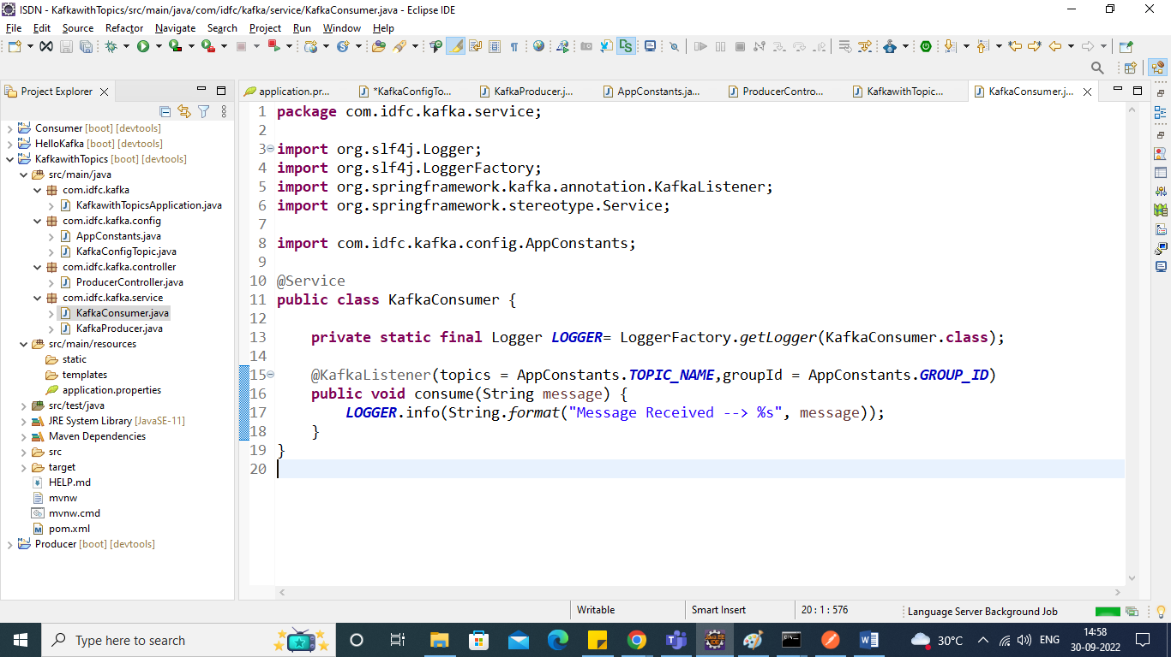

Check output in the Console.

